Hands-on Activity 1.1: Using Pseudo-code Statements and Flowchart Symbols
Hands-on Activity 1.1
Course Code: CPE007 | Program: Computer Engineering
Course Title: Data Structures and Algorithms | Date Performed:
Section: CPE11S1 | Date Submitted:
Name(s): James Daniel M. Verano | Instructor: Sir. Jimlord
6. Output
Problem 1: (Infinite Algorithm) The problem with this algorithm is that, some of the steps appear more than once, i.e. step 5 get second number, step 7, get third number, etc. One could shorten the algorithm or flowchart as follows:

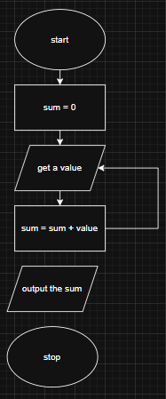

start
sum=0
get a value
sum = sum + value
go to step 3 to get the next value
output the sum
stop

Problem 2: (Finite Algorithm) The new list of numbers is given as 26, 49, 498, 9387, 48962, 1, -1. The value –1 is a unique number since all other numbers are positive. This means that the procedure will stop once -1 is encountered.

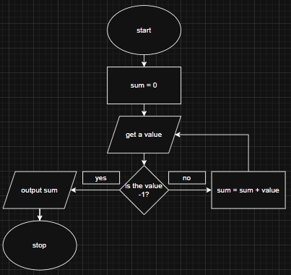

Start
Sum=0
Get a value
If the value = -1, go to step 7
Add to sum (sum = sum + value)
Go to step 3 to get the next value
Output the sum
Stop

7. Supplementary Activity
- Design an algorithm and the corresponding flowchart for finding the sum of the numbers 2, 4, 6, 8, …, n (output: Algorithm and Flowchart)
start
n = 0, sum = 0, current_number = 2
input value for n
if current_number is <= n, output n
else current_number = current_number + 2
stop

FLOWCHART
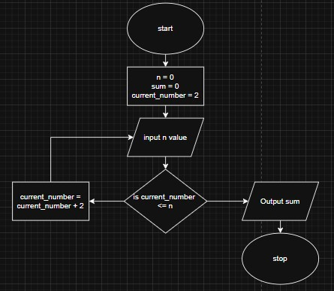
- Write an algorithm to read 100 numbers and then display the sum.
start
sum = 0, amount_value = 0
input a value
sum = sum + value
amount_value = amount_value + 1
if amount_value = 100, step 6
else go to step 3
output sum
stop

- Write an algorithm to read two numbers then display the largest.
start
firstValue = 0, secondValue = 0
input first value
input second value
if the firstValue is > secondValue, output firstValue
else, output secondValue
Stop

- Write an algorithm to read two numbers then display the smallest
start
firstValue = 0, secondValue = 0
input first value
input second value
if the firstValue is < secondValue, output firstValue
else, output secondValue
Stop

- Write an algorithm to read three numbers then display the largest.
start
firstValue = 0, secondValue = 0, thirdValue = 0
input first value
input second value
input third value
if the firstValue is > secondValue & thirdValue, output firstValue
if the secondValue > firstValue & thirdValue, output secondValue
else output thirdValue
Stop

- Write an algorithm to read 100 numbers then display the largest.
start
current_number = 0, amount_value = 0, large_number = 0
input a value
amount_value = amount_value + 1
if current_number > large_number = current_number = large_number
if amount_value = 100, output large_number
else go to step 3
stop

8. Conclusion
9. Assessment Rubric

